# Social media content and metrics plan guide

## Project scenario

As a digital marketing analyst, you are in charge of developing a comprehensive social media content and metrics plan for Friska, with the objective of increasing brand awareness and engagement on Facebook. Your objective is to develop a social media content and metrics plan and provide recommendations to increase brand awareness and improve user engagement. Fill out the tables in the guide below to help process and organize your thoughts.

## Step-by-step instructions

### Step 1: Understand your product.

The first step in developing a social media content and metrics plan is to understand the product you want to promote. Questions to consider include:

* What are the product’s features?
* What are the product’s benefits?
* What are the product’s unique selling points?
* How does the product differ from competitors in the market?

Here’s what we know about Friska’s sustainable deodorant specifics:

#### Sustainability focus

Friska is committed to sustainability and reducing its environmental impact. The brand uses recyclable materials and eco-friendly practices in its product development and packaging, helping to decrease its carbon footprint.

#### Effective odor protection

Friska's deodorant products are designed to provide effective and long-lasting odor protection. You can count on them to keep you feeling fresh and confident throughout the day.

#### Variety of scents and formulations

Friska offers a diverse range of scents and formulations, ensuring that there's a deodorant suitable for everyone. Whether you prefer subtle, floral scents, or something more invigorating, you can find a product that suits your preferences.

#### Exceptional customer support

Friska is committed to providing exceptional customer support. Whether you have questions, concerns, or need assistance with your purchase, you can count on its dedicated customer service team to provide assistance and guidance.

#### Satisfaction guarantee

Friska stands behind the quality of its products and guarantees a satisfying experience for its customers. If you're not happy with your purchase, the company is likely to have a return or satisfaction guarantee policy in place to ensure your peace of mind.

#### Embracing a sustainable lifestyle

By choosing Friska's deodorant products, you are not only improving your daily personal care routine but also contributing to a more sustainable lifestyle. You're making a positive impact on both your life and the environment.

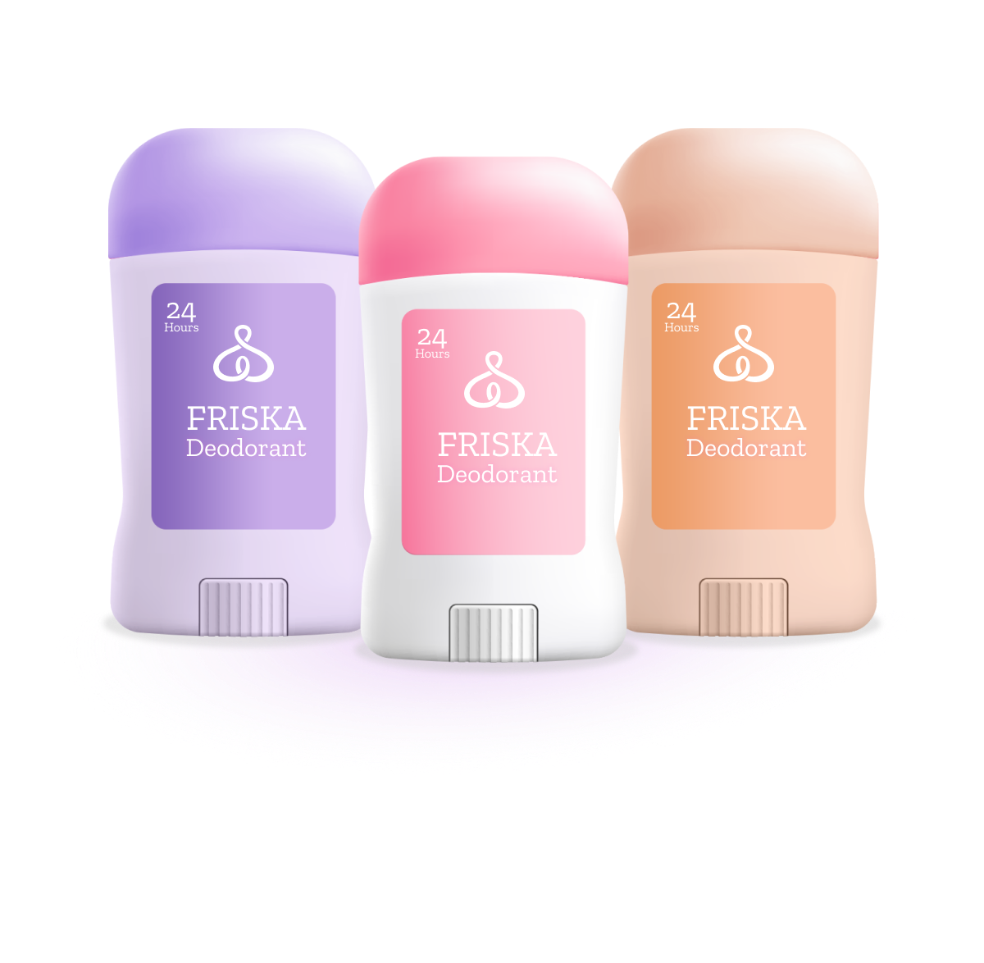

Why is it important to understand the product you want to promote? Write your answer in the space below.

| ***Understanding your product*** |  |
| --- | --- |

### Step 2: Set clear goals and SMART objectives

Define your social media marketing goals and objectives. These should align to your overall business goal. Your objectives should be written as [SMART objectives](https://www.coursera.org/learn/measurement-and-analysis/lecture/qGc4W/smart-objectives-for-social-media-marketing-initiatives) to provide you an opportunity to measure their performance and adjust as needed. When crafting SMART objectives, questions to consider include:

* Is the objective clearly outlined on what you want to achieve?
* Can you track the objective’s progress and evaluate its success?
* Is the objective realistic to achieve? Take into consideration the resources, budget, and the marketing team’s bandwidth.
* Does the objective align with the overall marketing goals?
* Does the objective have a specific time frame or deadline?

Friska’s overall marketing goals are:

1. **Promoting sustainability:** Friska aims to promote sustainability as a core value in its marketing efforts. The brand seeks to position itself as a leader in sustainable personal care by highlighting its use of recyclable materials, eco-friendly practices, and a reduced carbon footprint. This can attract environmentally conscious consumers.
2. **Emphasizing product effectiveness:** The brand's commitment to providing effective and long-lasting odor protection suggests that a primary marketing goal is to communicate the performance and reliability of its products. This goal is likely to attract consumers who prioritize the effectiveness of personal care items.
3. **Offering variety and choice:** Friska's range of scents and formulations indicates a goal to cater to a broad audience with diverse preferences. This allows the brand to attract a wide range of consumers, ensuring that there is a product for everyone.
4. **Providing exceptional customer support:** The emphasis on exceptional customer support suggests a goal to create a positive customer experience and build brand loyalty. This can lead to repeat business and positive word-of-mouth recommendations.
5. **Ensuring customer satisfaction:** Guaranteeing a satisfying experience reinforces the brand's commitment to quality and customer satisfaction. This marketing goal aims to build trust and confidence among potential customers.
6. **Inspiring a sustainable lifestyle:** Friska's marketing goal also seems to be centered around inspiring and encouraging customers to embrace a fresh and sustainable lifestyle. By using Friska’s products, customers are not only improving their personal care routine but also contributing to a more sustainable world.

A SMART objective for the Friska deodorant is:

*Increase sales of Friska's sustainable deodorant by 20% within the next 12 months.*

* **Specific**: This objective clearly focuses on increasing sales of the sustainable deodorant product, which is a specific aspect of Friska's product line.
* **Measurable**: The increase of 20% provides a measurable target that can be tracked and assessed over the 12-month period.
* **Achievable**: This goal is realistic and achievable, assuming Friska's marketing strategies, distribution, and product quality can support this growth rate.
* **Relevant**: Given Friska's emphasis on sustainability, this objective is relevant to its brand identity and goals.
* **Time-bound**: The objective has a clear time frame of 12 months, providing a deadline for achieving the 20% sales increase.

Why is it important to align your product’s objectives to your overall business goal? Write your answer in the space below.

| ***Aligning objectives and overall goal*** |  |
| --- | --- |

### Step 3: Define your target audience

Determine who your ideal target audience is. Questions to consider include:

* What are their demographics?
* What are their interests?
* What are their values and beliefs related to your product?
* What are their pain points?
* What is their online behavior?
* Which social media platforms do they most frequently use?

This information will help guide you in creating content that is relevant and engaging for your audience. In addition, create a [target audience profile](https://docs.google.com/document/d/1eWCzql_LkOlczVUUC_yRL3rcA4schdNoIVBLOlcf9vY/copy#heading=h.iv0zn41lhjes) to segment the audience most likely to buy your product. Jenny Appleby provides insights on the characteristics of Friska’s targeted audience. It is called a *marketing persona*.

## Screenshot of example target audience profile for Jenny Appleby.

What specific characteristics of Jenny Appleby relate to Friska’s target audience? Write your answer in the space below.

| ***Target audience characteristics*** |  |
| --- | --- |

### Step 4: Select relevant social media platforms

Now that you have an idea of who your target audience is, it’s time to choose the [social media platform](https://www.coursera.org/learn/measurement-and-analysis/lecture/pT50W/top-social-media-platforms) to focus your attention on for the social media content and metrics plan. Take into consideration the product’s objectives and how each social media platform has different capabilities and features. Choose the social media platform that is most [suitable for your specific strategy.](https://www.coursera.org/learn/measurement-and-analysis/lecture/XrvCh/the-suitability-of-social-media-platforms-for-specific-strategies) Questions to consider include:

* What are each platform’s content formats?
* What are each platform’s advertising options?
* What are each platform’s targeting capabilities?
* What engagement tools are compatible with each platform?
* What are each platform’s usage statistics and engagement metrics?
* What is my budget?
* Do I have the capability to stay up to date on all of the platform’s features and capabilities?

Taking into consideration everything you know about Friska and its target audience, you will focus the social media and metrics plan on Facebook, as you want to increase sales of Friska's sustainable deodorant by 20% within the next 12 months. The targeted segment—marketing persona specifically—will be best reached on that platform (based on their analyzed characteristics).

What makes Facebook a suitable platform for Friska’s social media content and metrics plan? What benefits can it provide for marketing your product? Write your answer in the space below.

| ***Social media platform*** |  |
| --- | --- |

### Step 5: Create a content strategy

Determine a plan for the type of content that will be created, how it will be distributed, and when it will be visible for users to view. Determine content themes, formats, and a calendar of when to post new content.

#### Content themes

To determine your content themes, consider the following:

* What product-related topics are most important to the target audience?
* How can content themes align with the overall business goals?
* Are there industry trends that the content can address?
* How can we differentiate our content from our competitors?

Friska’s content themes are:

* **Sustainability initiatives:** Highlight Friska's commitment to sustainability. Share posts about the brand's use of recyclable materials, eco-friendly practices, and its efforts to reduce its carbon footprint. Showcase how choosing Friska products aligns with a sustainable lifestyle.
* **Product features and benefits:** Create posts that detail the features and benefits of Friska's sustainable deodorants. Explain how they provide effective odor protection, use natural and ethically sourced ingredients. Highlight what sets your products apart.
* **Customer testimonials:** Share testimonials and reviews from satisfied customers who have experienced the benefits of using Friska's deodorants. User-generated content can be especially compelling.
* **Behind the scenes:** Take your audience behind the scenes of your production process to demonstrate your commitment to sustainability. Show how recyclable materials are used, or provide a glimpse into the manufacturing process.
* **Educational content:** Post informative articles, videos, or infographics related to personal care, sustainability, and ethical product choices. Share tips on adopting a more sustainable lifestyle and the importance of eco-friendly personal care products.
* **Variety of scents and formulations:** Showcase the different scents and formulations available, explaining the unique qualities of each one. Use visuals and descriptions to help customers choose the product that suits them best.
* **How-to guides:** Create how-to guides and tutorials on using Friska's deodorant products effectively. Offer tips for maximum freshness and longevity.
* **Sustainability news:** Share relevant news and updates about sustainability, eco-friendly practices, and ethical consumer choices. This demonstrates your brand's awareness of current environmental issues.
* **Customer engagement:** Encourage engagement by asking questions, running polls or surveys, and hosting contests or giveaways related to your sustainable deodorant products. This fosters a sense of community and involvement among your audience.
* **Exclusive promotions:** Share exclusive offers and promotions to incentivize purchases, such as discounts, buy-one-get-one deals, or limited-time bundles.
* **User-generated content:** Encourage customers to share their experiences using your products on Facebook. Repost user-generated content with their permission to build trust and authenticity.

#### Content formats

To determine your content formats, consider the following:

* Which content formats such as blog posts, videos, or infographics resonate most with the target audience?
* What resources are available to create content in different formats?
* Do certain platforms support different content formats better than others?
* What tools are available to help with content creation to distribute on platforms?

Friska’s content formats include high-quality images and videos on the products, infographics and how-to guides, customer testimonials and reviews, polls, and live question and answer (Q&A) webinars.

#### 

#### Content calendar

To determine your content calendar, consider the following:

* How often should you publish new content to maintain audience engagement?
* Are there key events, holidays, or seasons that could influence your content calendar (taking into account your product offer and industry)?
* Is there a plan in place to measure the performance of content published on different dates?

Tools such as Hootsuite, Buffer, or Later allow you to schedule posts ahead of time.

For Friska’s content calendar, there are planned weekly posts that include different content types. There is a mixture of promotional and informative information, and posts are scheduled to maintain consistency. View Friska’s content calendar below:

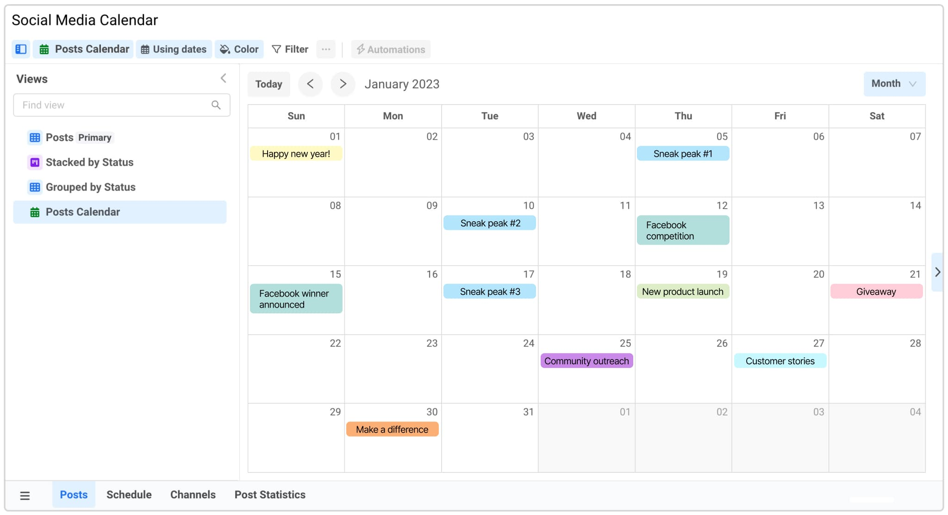

Why is it important to have a content strategy plan? What benefits can it provide for marketing your product? If you market new content too often, what effects could that bring? Write your answer in the space below.

| ***Content strategy plan*** |  |
| --- | --- |

### Step 6: Conduct keyword research

Determine a seed keyword for your product, and then conduct [keyword research](https://www.coursera.org/learn/measurement-and-analysis/supplement/Ng82s/steps-to-perform-keyword-research) to expand your keyword list and generate long-tail keywords. Use Google Keyword Planner to determine search volume (average monthly searches), competition, top of page bid, historical metrics (monthly and yearly changes), ad impression share, and a forecast of how keywords could perform. Questions to consider when determining a seed keyword include:

* Is the keyword directly related to the product?
* How often is the keyword searched for on search engines?
* Are there other similar keywords that would be more strategic to use?
* How many other competitor products are targeting the same keyword?
* Will this keyword remain relevant over time?

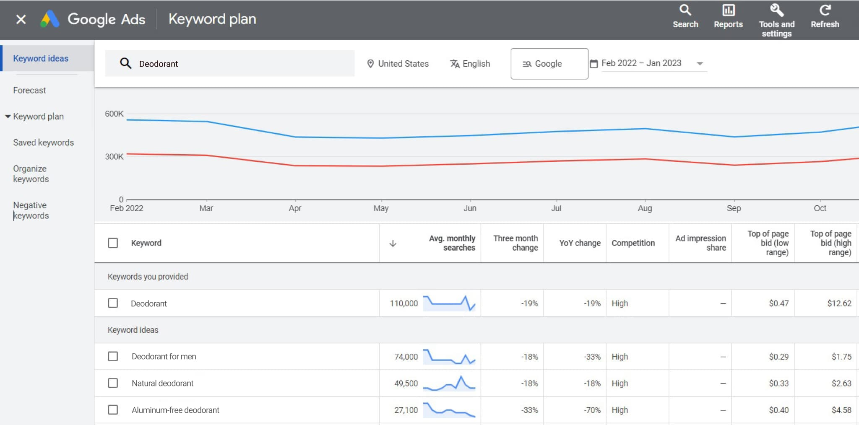

Notice that Friska’s seed keyword is deodorant. Google Keyword Planner provides the following information:

* **Keyword suggestions:** Deodorant for men, natural deodorant, and aluminum-free deodorant
* **Search volume:** You'll see the average monthly search volume for each keyword, which helps you gauge how popular or competitive these terms are.
* **Competition level:** Google Keyword Planner may provide an indication of the competition level for each keyword, which can help you understand how challenging it might be to rank for these terms in search engine results.
* **Ad impression share:** This data can show you how often your ads would be shown when targeting the keywords, based on your budget.
* **Top of page bid (low range):** This indicates the lower range of bid prices to have your ad shown at the top of the search results page for a specific keyword.
* **Top of page bid (high range):** This is the upper range of bid prices for top-of-page ad placement.

Additional information that can also be provided by Google Keyword Planner:

* **Keyword trends:** Google Keyword Planner may provide data on keyword trends, showing whether a keyword's popularity is increasing or decreasing over time.
* **Ad group ideas:** The tool can also suggest related keyword groupings, which can help you organize your advertising campaigns effectively.

Do you think the keywords generated by Google Keyword Planner resonate with your target audience? Why or why not? Write your answer in the space below.

| ***Keywords*** |  |
| --- | --- |

### Step 7: Create high-quality content

Create high-quality content that highlights your product. This can include product images, videos, infographics, blog posts, or user-generated content. Ensure that the content is engaging, informative, and visually appealing. Questions to consider include:

* Does the content resonate with the target audience (messaging and tone)?
* Are the product’s key features and benefits highlighted?
* Is the content visually appealing and consistent with the brand identity?
* Is there a call to action on next steps for users such as steps to complete a purchase?
* Does the content encourage user engagement such as sharing, reposting, or commenting on the content?

Friska’s catchphrase *Elevate Your Daily Routine with Friska's Sustainable Deodorant* pairs well with the following high-quality content to share with their audience:

In a world that's becoming increasingly eco-conscious, personal care choices matter. Friska, a leading personal care brand, is dedicated to transforming your daily routine with sustainable deodorant products that not only keep you fresh but also make a positive impact on the environment.

#### Our difference

##### Eco-friendly commitment

At Friska, sustainability isn't just a buzzword; it's a way of life. Our deodorants are crafted with the environment in mind. We use recyclable materials and eco-friendly practices throughout our production process, helping reduce our carbon footprint.

##### A deodorant for everyone

Friska understands that one size doesn't fit all. That's why we offer a range of scents and formulations, ensuring there's a deodorant for everyone. Whether you prefer the gentle embrace of a floral scent or the invigorating kick of a more vibrant fragrance, we have you covered.

#### Our promise to you

##### Exceptional customer support

When you choose Friska, you're not just buying a product; you're joining a community. Our dedicated customer support team is here to assist you with any questions or concerns. Your satisfaction is our priority.

##### Satisfaction guarantee

We stand behind the quality of our sustainable deodorants. If, for any reason, you're not completely satisfied with your purchase, we have a satisfaction guarantee in place to ensure your peace of mind.

##### Embrace a fresh and sustainable lifestyle

By choosing Friska's sustainable deodorant, you're making a statement—a statement about the kind of world you want to live in. You're not just upgrading your daily routine; you're contributing to a more sustainable future. Make a difference in your life and the world.

##### Join the Friska movement

It's time to take a step forward. Embrace a fresh and sustainable lifestyle. Elevate your daily routine with Friska's sustainable deodorant products. Choose quality, choose sustainability, choose Friska.

What could be a drawback if your marketing content is not high-quality? Write your answer in the space below.

| ***High-quality content*** |  |
| --- | --- |

### Step 8: Promote the content

Develop a strategy to promote the content on the social media platform that you’re focusing on. This includes catchy headlines, captions, and calls to action. Consider the following as options:

#### Catchy headlines

* *Freshness meets sustainability: Friska's deodorant unveiled!*
* *Elevate your routine: Discover Friska's sustainable deodorant!*
* *The future of deodorant is here: Meet Friska's eco-friendly solution!*
* *Embrace freshness, embrace change: Friska's green deodorant*
* *Your daily routine, upgraded: Friska's sustainable deodorant*

#### Engaging captions

* *Our deodorants are about feeling good with effective protection.*
* *Variety is the spice of life, and it's the essence of our deodorants. Find your perfect scent with Friska.*
* *Join our community of eco-conscious individuals and make a difference, one deodorant at a time.*

#### Calls to action (CTAs)

* *Upgrade your daily routine with Friska. Shop now to experience the difference.*
* *Ready to embrace a sustainable lifestyle? Start with your deodorant. Shop Friska today.*
* *Learn more about our sustainability journey. Explore the Friska difference.*
* *Join the Friska family and share your sustainable journey with us. Follow us for inspiration.*
* *Not just deodorant—it's a commitment. Try Friska's sustainable deodorant and make a change today.*

Does the content include keywords? If so, what are the keywords? Write your answer in the space below.

| ***Keywords*** |  |
| --- | --- |

What is a catchy headline? Why do you think it is catchy? Write your answer in the space below.

| ***Catchy headline*** |  |
| --- | --- |

What is an engaging caption? Why do you think it is engaging? Write your answer in the space below.

| ***Engaging caption*** |  |
| --- | --- |

What are the calls to action? How are they written to persuade the user to do something? Write your answer in the space below.

| ***Calls to action*** |  |
| --- | --- |

Why is it important to promote your content? What aspect of Friska’s content catches a user’s attention? Write your answer in the space below.

| ***Promote content*** |  |
| --- | --- |

### Step 9: Monitor metrics and analytics

Regularly monitor and analyze key performance indicators to assess campaigns and adjust where needed. Use Google Analytics 4 to run different tests to determine the campaigns:

* New users acquired
* Engagement rate
* Conversion rate

How do you monitor the performance of your post? Write your answer in the space below.

| ***Monitor performance plan*** |  |
| --- | --- |

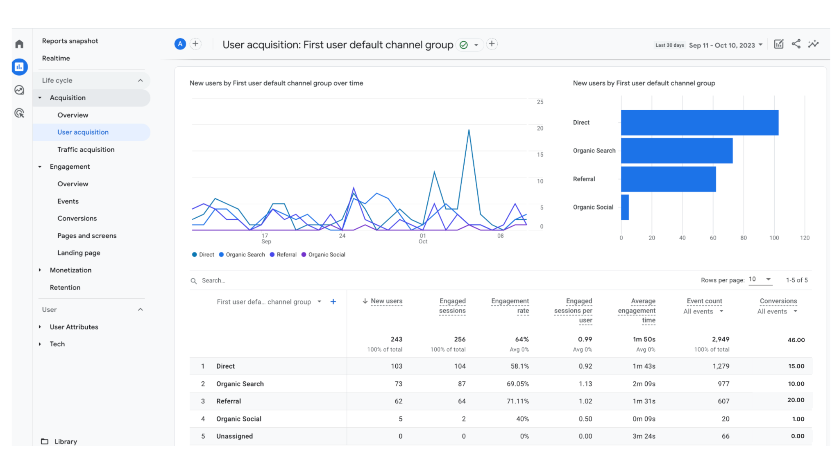

The best way to measure the click-through rate for each page is by using Urchin Tracking Module (UTM) tracking. UTM tracking involves adding a code to any URLs you share on social—think blog posts or product links. This enables you to see exactly how much traffic is coming to your site from specific social media channels, posts, and ads in Google Analytics 4.

Knowing that 64 engaged sessions on the website were generated through that social media's one and only post, and that the post generated 1,000 impressions on Facebook, you calculate the click-through rate as:

CTR = *(Engaged sessions/Impressions) * 100*

In this case:

* Engaged sessions = 64
* Impressions = 1,000

Now, plug these values into the formula:

CTR = (64 / 1,000) * 100

CTR = (0.064) * 100

CTR = 6.4%

The click-through rate for the social media post on Facebook is 6.4%.

What do you notice about Friska’s click-through rate? Why do you think it’s that number? What strategy could be implemented to improve it, and so on? Write your answer in the space below.

| ***Metrics and analytics*** |  |
| --- | --- |

### Step 10: Engage with the community

Once you’ve published content to a social media platform, monitor the content’s comments, messages, and mentions related to your product. Engage with audience members by answering questions and responding to comments promptly. You can encourage user-generated content by running contests or campaigns that involve your community. In addition, monitor and moderate your content to maintain a positive and respectful online environment. Questions to consider include:

* How can you address your audience’s pain points through engagement efforts?
* Are you using a tone and voice that resonate with your audience?
* What is your plan for handling both positive and negative interactions?
* How are you collecting and analyzing community feedback to provide your audience with more value?

Friska has engaged with its community through various strategies that involve active participation, responsiveness, and community building:

#### Prompt response to comments and questions

Friska maintains an active presence on its social media platforms and website. The company has a dedicated team in place to respond promptly to comments, questions, and inquiries from its community. Whether it's a query about the company’s products, sustainability practices, or general feedback, Friska ensures that no comment goes unnoticed.

#### Engaging content

Friska regularly posts engaging content that sparks conversations. This content might include educational posts about sustainability, product spotlights, customer testimonials, or even fun and relatable posts related to daily routines and personal care. These posts encourage community members to comment, share their thoughts, and ask questions.

#### User-generated content campaigns

To involve the community and showcase real-life experiences, Friska runs user-generated content campaigns. These campaigns encourage customers to share photos or stories of themselves using Friska products. By featuring this content on its website and social media, Friska not only highlights satisfied customers but also fosters a sense of community involvement.

#### Contests and giveaways

Friska regularly organizes contests and giveaways that require community participation. These contests can range from creative photo contests featuring Friska products to sustainability challenges that encourage followers to share their eco-friendly practices. Prizes and recognition are offered to winners, motivating participation.

#### Interactive live sessions

Friska may host live sessions on social media platforms, where it engages with the community in real time. These sessions can include product demonstrations, sustainability discussions, or Q&A sessions. They provide an opportunity for direct interaction and immediate responses to questions and comments.

#### Community forums or groups

Friska might also create dedicated community forums or groups on social media or its website. These platforms allow community members to connect, share experiences, and seek advice. Friska actively participates in these forums, fostering a sense of belonging and support.

#### Customer testimonials and stories

Friska showcases customer testimonials and success stories on its website and social media. By sharing the experiences of satisfied customers, the company not only encourages user-generated content but also builds trust and credibility within the community.

#### Feedback channels

Friska maintains open feedback channels, such as surveys and direct messaging, to encourage community members to share their opinions and suggestions. This input is valuable in improving products and services and demonstrates a commitment to customer satisfaction.

How could engaging with a product’s community support your overall business goal? What are the benefits of community engagement? Write your answer in the space below.

| ***Community engagement*** |  |
| --- | --- |

### Step 11: Analyze competitors

Analyzing competitors provides insights on what strategies are effective in your industry. These insights inform you of gaps and opportunities of how to improve and refine your social media strategy, staying competitive in the social media landscape. Questions to consider include:

* What type of content are your competitors posting?
* How frequent are your competitors posting?
* Are your competitors adopting new features or trends?

Friska’s competitors are FreshGuard Pro, OrderShield, and Aroma Defense. Use tools such as Sprout Social or Semrush to conduct a social media audit on your competition. Below are the steps to conduct competitor analysis on Friska’s competitors.

1. **Identify competitors**

* FreshGuard Pro:
  + Facebook:<https://www.facebook.com/freshguardpro>
  + X:<https://twitter.com/FreshGuardPro>
  + Instagram:<https://www.instagram.com/freshguardpro>
* OrderShield:
  + Facebook:<https://www.facebook.com/ordershield>
  + X:<https://twitter.com/OrderShieldInc>
  + Instagram:<https://www.instagram.com/ordershield_official>
* Aroma Defense:
  + Facebook:<https://www.facebook.com/aromadefense>
  + X:<https://twitter.com/AromaDefense>
  + Instagram:<https://www.instagram.com/aromadefensebrand>

1. **Gather data**

* FreshGuard Pro:
  + Facebook: 5,000 followers, 100 likes, 20 comments per post, 5 posts per week
  + X: 2,500 followers, 50 retweets, 10 replies per tweet, 7 tweets per week
  + Instagram: 3,000 followers, 200 likes, 30 comments per post, 4 posts per week
* OrderShield:
  + Facebook: 3,500 followers, 80 likes, 15 comments per post, 3 posts per week
  + X: 1,800 followers, 40 retweets, 8 replies per tweet, 5 tweets per week
  + Instagram: 2,200 followers, 150 likes, 20 comments per post, 6 posts per week
* Aroma Defense:
  + Facebook: 4,000 followers, 120 likes, 25 comments per post, 4 posts per week
  + X: 2,200 followers, 60 retweets, 12 replies per tweet, 6 tweets per week
  + Instagram: 3,500 followers, 180 likes, 35 comments per post, 5 posts per week

1. **Content analysis**

* FreshGuard Pro posts a mix of product images, customer testimonials, and sustainability tips.
* OrderShield shares infographics on data security, cybersecurity news, and company updates.
* Aroma Defense focuses on visual content, showcasing different fragrance products and user-generated content featuring its products in use.

1. **Engagement metrics**

* FreshGuard Pro's most engaging posts are user-generated content featuring customers using their products.
* OrderShield's infographics on cybersecurity best practices tend to receive high engagement.
* Aroma Defense's posts featuring limited-time offers and discounts generate significant engagement.

1. **Follower growth**

* FreshGuard Pro's follower base has been steadily growing at a rate of 10% per month.
* OrderShield has experienced a recent spike in followers after a cybersecurity data breach incident.
* Aroma Defense has maintained consistent follower growth of 8% per month.

1. **Hashtags and keywords**

* FreshGuard Pro uses hashtags like #SustainabilityMatters and #EcoFriendlyProducts in its posts.
* OrderShield incorporates keywords such as *cybersecurity*, *data protection*, and *privacy* in its X posts.
* Aroma Defense uses hashtags like #FragranceLovers and #AromaHeaven in its Instagram posts.

1. **Paid advertising**

* FreshGuard Pro runs Facebook ads promoting its eco-friendly deodorants.
* OrderShield has sponsored posts on X to promote its cybersecurity services.
* Aroma Defense occasionally runs Instagram ads to highlight new product launches.

1. **Audience demographics**

* FreshGuard Pro's Facebook audience is primarily aged 25–45, with a 60% female and 40% male split.
* OrderShield's X audience consists of IT professionals and cybersecurity enthusiasts.
* Aroma Defense's Instagram followers are mostly aged 18–35, with a strong interest in beauty and self-care.

What insights can you conclude from Friska’s competitors? Write your answer in the space below. If needed, you can use a Google Sheet or Excel sheet to collect, organize, and analyze the information listed above.

| ***Competitor analysis*** |  |
| --- | --- |

### Step 12: Create reports

Regularly create reports that provide insights to your product’s social media platform performance. The reports should be created in a way that can be easily understood by stakeholders. Tools and templates to help you organize your findings could be manual with the help of Google Sheets and Slides or automated with social media reporting tools such as Sprout Social.

Questions to consider include:

* Is your report’s data organized and visually clean?
* Is your report easy to understand and adapted to the audience?
* Does your report help monitor and answer your marketing objectives?

Why is it important to share reports with stakeholders? Why is it important to create them regularly? Write your answer in the space below.

| ***Reports*** |  |
| --- | --- |

### Step 13: Allocate a budget

Determine a budget for advertising and promotional content. Ensure that your budget aligns with your objectives. Questions to consider include:

* Are you investing in the areas that directly contribute to achieving your goals?
* Are you budgeting for the creation of content and communication tools?
* Do you have a budget set aside for optimization efforts?

Knowing that Friska’s objective is to increase brand awareness and engagement on Facebook (*Increase sales of Friska's sustainable deodorant by 20.0% within the next 12 months*.), factors to consider in the budget are:

#### Define the key performance indicators (KPIs)

Start by defining specific KPIs that align with your objective. For brand awareness and engagement, KPIs might include metrics such as reach, impressions, engagement rate, likes, comments, shares, and click-through rates (CTRs).

#### Set a benchmark

Review past performance data if available or industry benchmarks to understand what kind of results you can reasonably expect with a given budget. This will provide a baseline for your budgeting.

#### Determine the duration

Since the objective is to increase brand awareness and engagement over the next 12 months, consider how you'll distribute your budget over the year. Will you run continuous campaigns, seasonal campaigns, or periodic promotions?

#### Allocate budget by campaign type

Different campaign types can achieve different objectives. Allocate a portion of the budget to various types of campaigns, such as awareness campaigns, engagement campaigns, and lead generation campaigns. Adjust the allocation based on your specific goals.

#### Consider your target audience

The size and characteristics of your target audience can influence the budget. A larger, broader audience might require a higher budget, while a more niche audience might be reached with a smaller budget.

#### A/B testing

Allocate a portion of the budget for A/B testing to optimize campaign performance. Experiment with different ad creatives, ad formats, targeting options, and ad copy to determine what resonates best with your audience.

#### Content creation and design

Consider the costs associated with creating high-quality content and visuals. This includes graphic design, video production, and copywriting. Well-crafted content can enhance engagement.

#### Ad spend and promotion

Determine how much you're willing to spend on Facebook ads, promoted posts, and boosted content. Set a daily or monthly ad spend limit for each campaign.

#### Monitoring and analytics

Budget for tools and resources to monitor and analyze campaign performance. You may need analytics tools or the expertise of a data analyst.

#### Contingency

It's wise to allocate a portion of the budget as a contingency for unexpected expenses or opportunities that may arise during the year.

| Total Annual Budget: $50,000 | | | | | | | | | | | |
| --- | --- | --- | --- | --- | --- | --- | --- | --- | --- | --- | --- |
| Jan | Feb | Mar | Apr | May | Jun | Jul | Aug | Sep | Oct | Nov | Dec |
| $3.5K | $3.5K | $3.5K | $3.5K | $3.5K | $3.5K | $3.5K | $3.5K | $3.5K | $3.5K | $3.5K | $3.5K |

**Allocation by campaign type**

#### Brand awareness campaigns: $20,000

These campaigns focus on reaching a broad audience to increase brand recognition and reach. They can include general brand messaging, product teasers, and sustainability highlights.

#### Engagement campaigns: $15,000

These campaigns aim to drive user interaction and engagement, including likes, comments, shares, and click-throughs to the website. They can include user-generated content contests, polls, and interactive posts.

#### Lead generation and conversion campaigns: $10,000

While the primary focus is on awareness and engagement, a portion of the budget is reserved for lead generation campaigns aimed at converting engaged users into leads or customers. These campaigns may include product promotions, lead capture forms, and offers.

#### Content creation and design: $5,000

This budget is allocated to produce high-quality content and visuals for the campaigns. It covers graphic design, video production, and copywriting.

#### Ad spend and promotion: $30,000

The majority of the budget is allocated to ad spend on Facebook, including promoted posts, sponsored ads, and boosted content. This budget will be distributed among different campaign types based on performance.

#### Monitoring and analytics: $2,500

This budget is for tools and resources to monitor and analyze campaign performance, including social media analytics tools or hiring a data analyst.

#### Contingency: $2,000

A small portion is set aside as a contingency for unexpected expenses or opportunities that may arise during the year.

Do you think Friska’s budget aligns with its objective? Why or why not? Write your answer in the space below.

| ***Budget*** |  |
| --- | --- |

### Step 14: Optimize content

Continuously analyze the product’s performance on social media platforms and adjust where necessary based on what the metrics reveal. In addition, adapt your strategy to stay up to date on emerging trends. Questions to consider include:

* Which metrics are most important to evaluate before optimizing content?
* How can you tailor your content to better resonate with your target audience?
* Are you reflecting the product’s value proposition and strategic keywords?

Based on what you know about Friska, what content would you optimize and why? Write your answer in the space below.

| ***Content optimization*** |  |
| --- | --- |

### Step 15: Consider compliance and ethical regulations

Take into consideration social media advertising regulations to ensure your content complies with platform policies and industry standards. You are responsible for staying up to date on this. Questions to consider include:

* Are you handling the audience's data and personal information ethically and in compliance with data protection laws?
* Are you obtaining proper consent for data collection and usage?
* Are there specific industry or government regulations that apply to your product that need to be adhered to?
* Have you worked with your legal department team to ensure compliance with your content?

Friska’s content on Facebook is compliant with regulations such as the General Data Protection Regulation (GDPR) and other data privacy and advertising guidelines:

#### Transparency and consent

Friska can be transparent with users about the data it collects and how it's used. It should obtain clear and informed consent from users for data processing activities, such as email subscriptions or personalized ads.

#### Data protection measures

Friska should implement robust data protection measures to safeguard user data. This includes encryption, secure storage, and access controls to prevent unauthorized access to sensitive information.

#### Cookie consent

Friska can ensure that its website and Facebook page include a cookie consent mechanism that complies with GDPR requirements. Users should be informed about the use of cookies and given the option to opt in or out.

#### Privacy policy

Maintain a comprehensive privacy policy that explains how user data is collected, used, and protected. This policy should be easily accessible from Friska's Facebook page and website.

#### Ad targeting and personalization

When running ads on Facebook, Friska should ensure that it complies with ad targeting regulations. Personalized ads should be based on user consent and offer an option to opt out.

#### User data rights

Respect user data rights, including the right to access, rectify, or delete personal information. Friska should have processes in place to accommodate these requests promptly.

#### Data minimization

Only collect the data that is necessary for the specified purposes. Avoid excessive or unnecessary data collection.

#### Age restrictions

Ensure that age-restricted products are not marketed to minors and implement age verification processes where applicable.

#### Data processor agreements

If Friska uses third-party tools or services that process user data, ensure that data processor agreements are in place to hold them accountable for compliance.

How does adhering to compliance and ethical regulations gain the trust of your customers and potential customers? Write your answer in the space below.

| ***Regulations*** |  |
| --- | --- |

### Step 16: Share feedback

Throughout this entire process, it’s important to continually update and share feedback and findings with your team and stakeholders. Questions to consider include:

* Did you keep your overall marketing goal in mind throughout the whole process?
* Did you make sure to take notes of any insights that could be of interest to your stakeholders?

### Create a presentation!

Now that you have gathered and analyzed Friska’s data, you are ready to develop a comprehensive social media and metrics plan to increase brand awareness and improve user engagement in a presentation format. Use either Google Slides or Microsoft Powerpoint and make it your own! Customize each slide as if you were going to present it to stakeholders. You can add speaking points to the notes section and even practice giving the presentation to stakeholders by speaking out loud. This will help prepare you for when the time comes to present a social media content and metrics plan for a real product. Your social media content and metrics plan should include:

* Goals
* Audience analysis
* Competitor analysis
* Social content audit
* Content types
* Content calendar
* Promotion and distribution content plan
* Results

When you’re ready, go back to [the assignment](https://www.coursera.org/learn/measurement-and-analysis/assignment-submission/53gou/activity-social-media-content-and-metrics-plan) to complete the reflective questions.